Eritrea

## GNI per capita and development level

The data set shows the GNI per capita and development level of the country each year.

## # A tibble: 19 x 5  
## country iso3c date GNIperCapita devCategory  
## <chr> <chr> <dbl> <dbl> <chr>   
## 1 Eritrea ERI 1996 615. Low Income   
## 2 Eritrea ERI 1998 675. Low Income   
## 3 Eritrea ERI 2000 629. Low Income   
## 4 Eritrea ERI 2002 649. Low Income   
## 5 Eritrea ERI 2003 603. Low Income   
## 6 Eritrea ERI 2004 584. Low Income   
## 7 Eritrea ERI 2005 577. Low Income   
## 8 Eritrea ERI 2006 554. Low Income   
## 9 Eritrea ERI 2007 548. Low Income   
## 10 Eritrea ERI 2008 483. Low Income   
## 11 Eritrea ERI 2009 492. Low Income   
## 12 Eritrea ERI 2010 495. Low Income   
## 13 Eritrea ERI 2011 531. Low Income   
## 14 Eritrea ERI 2012 234. Low Income   
## 15 Eritrea ERI 2013 234. Low Income   
## 16 Eritrea ERI 2014 228. Low Income   
## 17 Eritrea ERI 2015 228. Low Income   
## 18 Eritrea ERI 2016 228. Low Income   
## 19 Eritrea ERI 2017 228. Low Income

## GDP growth and economic growth classification

The data set shows the GDP growth and the ecomic growth classification of the country each year.

## # A tibble: 19 x 5  
## country iso3c date GDPannualGrowthRate GDPgrowthCategory4  
## <chr> <chr> <dbl> <dbl> <fct>   
## 1 Eritrea ERI 1996 9.26 fast growth   
## 2 Eritrea ERI 1998 1.77 slow growth   
## 3 Eritrea ERI 2000 -3.14 negative grwoth   
## 4 Eritrea ERI 2002 3.01 moderate growth   
## 5 Eritrea ERI 2003 -2.66 negative grwoth   
## 6 Eritrea ERI 2004 1.45 slow growth   
## 7 Eritrea ERI 2005 2.57 moderate growth   
## 8 Eritrea ERI 2006 -0.969 negative grwoth   
## 9 Eritrea ERI 2007 1.43 slow growth   
## 10 Eritrea ERI 2008 -9.78 negative grwoth   
## 11 Eritrea ERI 2009 3.88 moderate growth   
## 12 Eritrea ERI 2010 2.19 slow growth   
## 13 Eritrea ERI 2011 8.68 fast growth   
## 14 Eritrea ERI 2012 2.39 slow growth   
## 15 Eritrea ERI 2013 -4.64 negative grwoth   
## 16 Eritrea ERI 2014 3.37 moderate growth   
## 17 Eritrea ERI 2015 6.58 fast growth   
## 18 Eritrea ERI 2016 3.53 moderate growth   
## 19 Eritrea ERI 2017 3.50 moderate growth

## Development trend

The plot shows the development trend of the country.

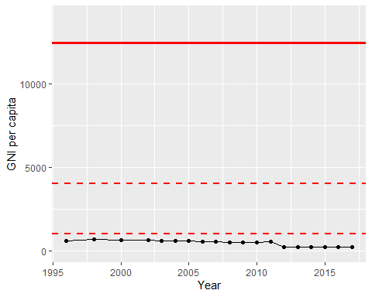

GNI Per Capita Trend